Order Of Service

Singing: Psalm 139a—CW page 116

Reading: Psalm 7

Opening Hymn: TLH 543

Reading: I John 2:1-17

Request Hymn: CW Supplement 769

Reading: Luke 24:36-53

Sermon Hymn: TLH 658

Sermon Text: Song Of Solomon 3:9

A Chariot Of Wood

Prayer

The Apostles’ Creed, TLH page 12

Holy Communion

The Lord's Prayer

The Blessing

Closing Hymn: TLH 45

* * * * * * * * * * *

Bible Study: Lambs: Genesis 6:22: Obey God Always
Sheep: Proverbs 10:11-12; Your Choice
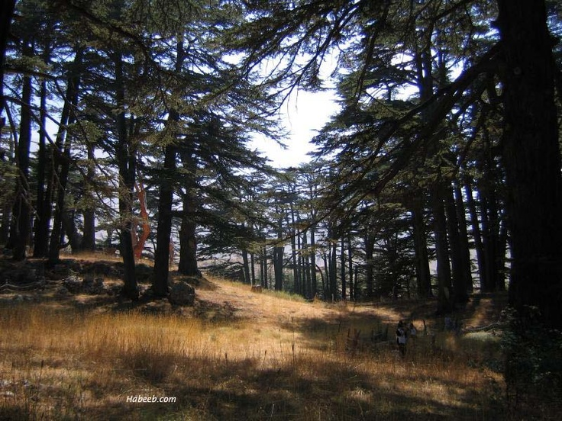

Cedars Of Lebanon

Water
Of
Life

12 June 2016

W A T E R O F L I F E

Independent Christian Church—Conservative Lutheran Doctrine

Worship Service: 9:30 a.m. Bible Study: 10:45 a.m.

Larry Cooper, Pastor E-Mail address:
111 N. Ridge Road lcooper@wateroflife.cc
Coon Valley, WI 54623 Web Site:
Phone: (608) 452-2105 www.wateroflife.cc

* * * * * * * * * * * * * * * * * * * * * * * * * * *

Sermon Text: Song Of Solomon 3:9

A Chariot Of Wood

* * * * * * * * * * * * * * * * * * * * * * * * * * *

Song of Solomon 3:9 King Solomon made himself a chariot of the wood of Lebanon.

War Chariots

One of the most terrifying sights on the battle field in Old Testament times was the sudden appearance of horses pulling chariots of iron. The children of Israel knew this from bitter experience. For comparison, consider the following verses:

Exodus 14:7 And he (Pharaoh) took six hundred chosen chariots, and all the chariots of Egypt, and captains over every one of them. :8 And the LORD hardened the heart of Pharaoh king of Egypt, and he pursued after the children of Israel.

Judges 4:13 And Sisera gathered together all his chariots, even nine hundred chariots of iron, and all the people that were with him, from Harosheth of the Gentiles unto the river of Kishon.

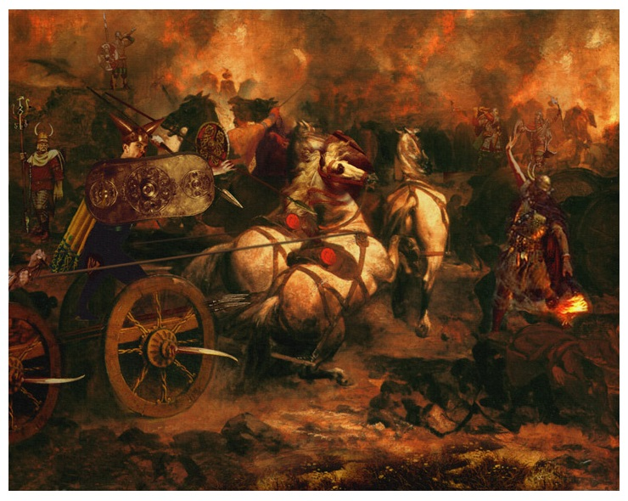

Now look at Song Of Solomon 3:9. King Solomon made himself a chariot of the wood of Lebanon.

Pharaoh had 600 chariots. Sisera had 900 chariots. Solomon had only one. Sisera’s chariots were made of iron. As most likely were the chariots of Pharaoh. Solomon’s chariot was made of wood.

Who would win the battle? It wasn’t even close! Pharaoh and Sisera never had a chance! A greater than Solomon is here!

